UNITED STATES
SECURITIES AND EXCHANGE COMMISSION
Washington, D.C. 20549

SCHEDULE 14A
Proxy Statement Pursuant to Section 14(a) of the
Securities Exchange Act of 1934

☒ | Filed by the Registrant

☐ | Filed by a Party other than the Registrant
Check the appropriate box:

☐ | Preliminary Proxy Statement

☐ | Confidential, for Use of the Commission Only (as permitted by Rule 14a-6(e)(2))

☐ | Definitive Proxy Statement

☐ | Definitive Additional Materials

☒ | Soliciting Material Pursuant to § 240.14a-12
CCC INTELLIGENT SOLUTIONS HOLDINGS, INC .
(Name of Registrant as Specified in its Charter)
Payment of Filing Fee (check the appropriate box):

☒ | No fee required.

☐ | Fee paid previously with preliminary materials

☐ | Fee computed on table in exhibit required by Item 25(b) per Exchange Act Rules 14a-6(i)(1) and 0-11

This Schedule 14A relates solely to preliminary communications made prior to furnishing stockholders of CCC Intelligence Solutions Holdings, Inc., a Delaware corporation (the “Company”), with a definitive proxy statement related to a proposed transaction with Mozart Parent, LLC, a Delaware limited liability company (“Parent”), and Mozart Merger Sub (DE), Inc., a Delaware corporation and wholly owned subsidiary of Parent (“Merger Sub”), pursuant to which the Merger Sub will merge with and into the Company (the “Merger”), with the Company surviving the Merger as a wholly owned subsidiary of Parent (collectively, the “Transaction”), upon the terms and subject to the conditions set forth in the Agreement and Plan of Merger, dated as of October 14, 2026 (the “Merger Agreement”), by and among the Company, Parent and Merger Sub.
This Schedule 14A filing consists of the following documents relating to the Transaction:
1. An email from the Company’s CEO with attached Frequently Asked Questions provided to employees on October 15, 2026.
2. An email from the Company provided to customers on October 15, 2026.
3. An email from the Company provided to certain business partners on October 15, 2026.
4. Social media posts made available on the Company’s LinkedIn and Facebook pages on October 15, 2026.
5. A transcript from the Company’s Town Hall with attached Town Hall Presentation provided to employees on October 15, 2026.
* * *

CCC All-Employee Letter

I am reaching out to share some exciting news about the future of CCC. This morning, we announced that CCC has entered into a definitive agreement to be acquired by a consortium led by GTCR, and including Elliott Investment Management. This transaction is a recognition of the strength of our technology, the trust our customers and partners place in us and, above all, the vision, dedication and ingenuity of our team. You can read the press release we issued here.
For more than 40 years, CCC has advanced the insurance economy, helping our customers move with the pace of change. When we returned to the public markets in 2021, we did so with a clear conviction that CCC could continue to drive our offering – and our industry – forward, with deliberate investments in technology, AI and our connected network. Today, CCC is a scaled provider of intelligent solutions that combines AI, insights, ecosystem connectivity and deeply integrated workflows to help our customers navigate complexity and achieve better outcomes. That progress is reflected not only in our technology leadership, but also in the strong adoption of our solutions across the markets we serve. We have made significant progress on major renewals and expansions across the insurance, automotive and OEM markets, creating a strong foundation for continued investment and growth.
We believe GTCR and Elliott are great partners for CCC’s next chapter and will help us build on the momentum we have created together. Like us, they believe that significant investment in our people, products and services is vital to scaling our brand and driving growth. They also recognize that our people are key to CCC’s success.
GTCR and Elliott both bring extensive experience supporting and growing leading businesses. GTCR has a long history of partnering with technology-enabled companies to help accelerate growth, strengthen capabilities and support innovation, while Elliott brings broad experience working with businesses that leverage data, software and analytics to deliver value to their customers and drive long-term success. Together, they bring valuable insight, resources and a long-term perspective, along with a shared commitment to supporting our continued growth. With GTCR’s and Elliott’s support, we will accelerate the AI and agentic capabilities our customers want from us, expand the network at the center of our platform and continue to develop and build our world class team. Simply put, we will be well positioned to build on CCC’s momentum and continue creating intelligent solutions that keep people’s lives moving forward when it matters most.
While this is an important day for CCC, this announcement is just the first step in the process, and nothing is changing today. The transaction is expected to close in the first quarter of 2027, subject to customary closing conditions, including the receipt of required regulatory approvals and the approval of CCC stockholders. Until then, CCC will continue to operate as an independent company, and it remains business as usual for all of us at CCC.
Our focus remains unchanged: delivering the technology, service and innovation our customers rely on while advancing our vision and growth strategy. I ask that you remain focused on your day-to-day responsibilities and continue bringing the commitment to excellence that has helped build CCC into the company it is today.

We will hold an employee town hall today at 10:00 AM CT to discuss the announcement in more detail, and I have attached an FAQ to help address some of the questions you may have. Please keep in mind that there are still many details to work through between now and closing, and we will continue to provide updates as we move through this process.
Our proven track record, together with the talent and commitment of this team, gives me tremendous confidence in the opportunities ahead. On behalf of our Board of Directors and management team, thank you for all you have done to build CCC and for all you will continue to do in this next chapter.
Githesh
Cautionary Statement Regarding Forward-Looking Statements
This communication contains forward-looking statements within the meaning of Section 27A of the Securities Act of 1933, as amended (the “Securities Act”), and Section 21E of the Securities Exchange Act of 1934, as amended (the “Exchange Act”). In some cases, you can identify forward-looking statements by the following words: “may,” “will,” “could,” “would,” “should,” “expect,” “intend,” “plan,” “anticipate,” “believe,” “estimate,” “predict,” “project,” “potential,” “continue,” “ongoing” or the negative of these terms or other comparable terminology, although not all forward-looking statements contain these words. These statements involve risks, uncertainties and other factors that may cause actual results, levels of activity, performance or achievements to be materially different from the information expressed or implied by these forward-looking statements. Forward-looking statements in this communication include, but are not limited to, statements regarding the proposed transaction, the expected timing of completion of the transaction, the ability of the parties to consummate the transaction and the satisfaction of the conditions precedent to the consummation of the transaction, including the receipt of stockholder approval, expiration or termination of applicable waiting periods under the Hart-Scott-Rodino Antitrust Improvements Act of 1976, and the expected benefits of the transaction.
These forward-looking statements are subject to a number of risks, uncertainties and assumptions, including, among others: the occurrence of any event, change or other circumstances that could give rise to the termination of the definitive transaction documents, including circumstances requiring payment of a termination fee pursuant to the definitive transaction documents; the failure to obtain stockholder approval of the transaction or the failure to satisfy other conditions to completion of the transaction; the risk that regulatory approvals required for the transaction may not be obtained in a timely manner or at all, or may be obtained subject to conditions that are not anticipated or that could adversely affect GTCR, Elliott or the Company or the expected benefits of the transaction; the failure to satisfy the other conditions to the consummation of the transaction on a timely basis or at all; risks related to the disruption of management’s attention from the Company’s ongoing business operations due to the transaction; the effect of the announcement or pendency of the transaction on the Company’s business relationships, operating results and business generally; the risk that the transaction may not be completed in the time frame expected by the parties or at all; the risk that any announcements relating to the transaction could have adverse effects on the market price of the Company’s common stock; the risk of any unexpected costs, expenses, liabilities or delays resulting from the transaction; the risk of any litigation related to the transaction; the possibility that competing offers will be made; the risk that certain restrictions during the pendency of the proposed transaction may impact the Company’s ability to pursue certain business opportunities or strategic transactions and various other risks that could

cause future results to differ from those expressed by the forward-looking statements included in this communication that are described in the Company’s reports filed with the Securities and Exchange Commission (the “SEC”), including the Company’s Annual Report on Form 10-K for the fiscal year ended December 31, 2025 and subsequently filed Quarterly Reports on Form 10-Q. You are cautioned not to place undue reliance on these forward-looking statements, which speak only as of the date of this communication. Except as required by applicable law, the Company does not undertake any obligation to publicly update or revise any forward-looking statements because of new information, future events or otherwise.
Additional Information and Where to Find It
This communication is being made in respect of the proposed acquisition of the Company by affiliates of GTCR or Elliott and related transactions (collectively, the “proposed transaction”). In accordance with the definitive transaction documents, a meeting of the stockholders of the Company will be announced as promptly as practicable to seek the Company’s stockholder approval in connection with the proposed transaction. The Company intends to file relevant materials with the SEC, including preliminary and definitive proxy statements relating to the proposed transaction. The definitive proxy statement (the “Proxy Statement”) will be mailed to the Company’s stockholders. This communication is not a substitute for the Proxy Statement or any other document that may be filed by the Company with the SEC or sent to its stockholders in connection with the proposed transaction. BEFORE MAKING ANY DECISION, THE COMPANY’S STOCKHOLDERS AND INVESTORS ARE URGED TO CAREFULLY READ THE PROXY STATEMENT (INCLUDING ANY AMENDMENTS OR SUPPLEMENTS THERETO) AND ANY OTHER RELEVANT DOCUMENTS FILED OR TO BE FILED WITH THE SEC IN CONNECTION WITH THE PROPOSED TRANSACTION OR INCORPORATED BY REFERENCE INTO THE PROXY STATEMENT AS, IF AND WHEN THEY BECOME AVAILABLE BECAUSE THEY WILL CONTAIN IMPORTANT INFORMATION ABOUT THE COMPANY, GTCR or Elliott AND THE PROPOSED TRANSACTION. Investors and security holders will be able to obtain a free copy of the Proxy Statement (when available) as well as other documents filed by the Company with the SEC through the website maintained by the SEC at www.sec.gov. Copies of the documents filed with the SEC by the Company will be available free of charge on the Company’s website at https://ir.cccis.com or by contacting the Company’s investor relations department at IR@cccis.com.
Participants in the Solicitation
The Company and its directors and executive officers may be considered participants in the solicitation of proxies from the Company’s stockholders in connection with the proposed transaction. Information about the directors and executive officers of the Company, including a description of their beneficial ownership of the Company’s securities, is set forth in the Company’s proxy statement for its 2026 annual meeting of stockholders, which was filed with the SEC on April 7, 2026 (the “Annual Meeting Proxy Statement”). To the extent the holdings of the Company’s securities by its directors or executive officers have changed since the amounts set forth in the Annual Meeting Proxy Statement, such changes have been or will be reflected on Forms 3, 4 and 5 filed with the SEC. Other information regarding the participants in the proxy solicitation and a description of their direct and indirect interests, by security holdings or otherwise, in the proposed transaction will be contained in the Proxy Statement and in other relevant materials to be filed with the SEC regarding the proposed transaction when they become available. You may obtain these documents (when they become available) as described above.

CCC Employee FAQ

1. | What was announced?

 |  |  | CCC announced that it has entered into a definitive agreement to be acquired by a consortium led by GTCR, and including Elliott Investment Management.

 |  |  | Under the terms of the agreement, CCC stockholders will receive $7.75 per share in cash for each share of CCC common stock, representing a premium of approximately 44% to CCC’s unaffected closing stock price on July 9, 2026, the last trading day prior to media speculation regarding a potential sale of CCC, and a premium of approximately 59% to the 30-day average price as of July 9, 2026.

 |  |  | Upon closing of the transaction, CCC will become a private company.

 |  |  | With GTCR’s and Elliott’s experience and resources, CCC will be even better positioned to accelerate the AI and agentic capabilities our customers want from us, expand the network at the center of our platform, and develop and build our world class team.

2. | Why this acquisition? Why now?

 |  |  | We believe GTCR and Elliott are great partners for CCC’s next chapter and will help us build on the momentum we have created together.

 |  |  | With their support, CCC will accelerate the AI and agentic capabilities our customers want from us, expand the network at the center of the platform and continue to develop and build our world class team.

 |  |  | In addition, as a private company, we will also have less exposure to volatile financial markets.

 |  |  | We look forward to what we can achieve together.

3. | Who are GTCR and Elliott? Why are they the right partners for CCC?

 |  |  | GTCR and Elliott are leading investment firms with extensive experience supporting and growing businesses.

 |  |  | GTCR is focused on investing in and building businesses across the technology, healthcare, financial services and business services sectors.

 |  |  | Elliott is a leading investment firm and one of the oldest investment managers of its kind under continuous management since 1977, with an established history of investment in technology private equity.

 |  |  | Together, they bring valuable insights, resources and a long-term perspective, as well as a shared commitment to supporting our continued growth.

 |  |  | With GTCR’s and Elliott’s support, we will be even better positioned to accelerate the AI and agentic capabilities our customers want from us, expand the network at the center of our platform, and continue to develop and build our world class team.

4. | What does this mean for me? Will this announcement have an immediate impact on day-to-day operations? How does this impact my responsibilities?

 |  |  | While this partnership will mean a change in ownership of CCC, our day-to-day operations and strategy do not change.

 |  |  | Our shared values will remain core to the work that we do every day and we look forward to continuing to execute on the opportunities ahead of us.

 |  |  | As we work through this process, we are counting on you to remain focused on your day-to-day responsibilities and serving our customers with excellence as you always have.

5. | Will there be changes to compensation or benefits?

 |  |  | It remains business as usual, and nothing is changing today. We continue to operate as an independent company, and you will continue to be paid and receive benefits as usual.

 |  |  | If there are any changes following the closing of the transaction, we will inform you well in advance.

6. | Will there be any changes to reporting structures?

 |  |  | It remains business as usual, and nothing is changing today.

 |  |  | Over the coming months, we’ll be working collaboratively with GTCR and Elliott to assess the organization as we prepare to start operating as a private company.

 |  |  | If there are any changes following the closing of the transaction, we will keep you informed.

7. | Will there be layoffs?

 |  |  | It remains business as usual, and nothing is changing today.

 |  |  | As with any transaction, we expect there will be some changes. For example, as we transition from a publicly listed company to a private company, there will be some duties related to being a publicly traded company that will not be required as a private company.

 |  |  | We will be as transparent as possible and will continue to treat our teams with respect as we have done in the past.

8. | Will CCC keep its name and brand?

 |  |  | We do not expect any changes to the CCC name or branding.

9. | What will happen to CCC’s leadership?

 |  |  | Our leadership team remains in place, and it is business as usual with regard to everyone’s roles and responsibilities.

10. | What will happen to CCC’s headquarters and offices?

 |  |  | It remains business as usual, and nothing is changing today.

11. | What does it mean to become a private company?

 |  |  | Becoming a private company means that, following completion of the transaction, CCC stock will no longer be listed or traded on Nasdaq, and we will cease to be an SEC-reporting company.

 |  |  | In other words, we will effectively have one ownership group instead of many public investors.

 |  |  | During the period between now and the closing of the transaction, which is expected in the first quarter of 2027, CCC remains a publicly owned company, and we are operating as usual.

12. | What can we do as a private company that we couldn’t do before?

 |  |  | Becoming a private company will allow us to be more flexible in our investments.

 |  |  | As a private company, CCC will accelerate the AI and agentic capabilities our customers want from us, expand the network at the center of our platform and continue to develop and build our world class team.

 |  |  | Ultimately, we expect to be better positioned to create value for our customers.

13. | What are some of the differences in operating as a public company versus a privately held company?

 |  |  | A primary difference is who provides the capital to make investments.

 |  |  | Public companies have many stockholders who invest their money in the company, while private companies are typically owned by a single company or a small number of investors.

 |  |  | Once the transaction is complete, CCC will no longer be traded on Nasdaq.

 |  |  | From a day-to-day operations perspective, it remains business as usual.

 |  |  | Regardless of our corporate structure, our people, strategy and commitment to our customers remain the keys to our success.

14. | What will happen to my CCC shares, stock options, RSUs and PSUs?

 |  |  | Employees who are stockholders of CCC will receive $7.75 in cash for each share of CCC common stock upon closing of the acquisition.

 |  |  | If you hold CCC equity awards (i.e., stock options, RSUs, or PSUs), they will be treated as follows in connection with the transaction:

 | a. | Stock Options: At closing, each stock option (vested or unvested) will be cancelled. If the stock option’s exercise price is below $7.75, you will receive a cash payment, less applicable tax withholding, equal to (i) $7.75 minus the exercise price, multiplied by (ii) the number of shares subject to the option. Options with an exercise price of $7.75 or more will be automatically cancelled without payment.

 | b. | RSUs and PSUs: At closing, each unvested RSUs and PSUs will be converted into a restricted cash award equal to (i) $7.75 multiplied by (ii) the total number of shares subject to those RSUs and PSUs. For PSUs, the number of shares will be based on the greater of target and actual performance. Each portion of the restricted cash award will vest on the same schedule and terms that applied to the RSUs or PSUs it replaces. Each vested portion will be paid, less applicable tax withholding, no later than the second regularly scheduled payroll date after it vests.

15. | Can I continue to buy or sell CCC stock?

 |  |  | Until the transaction closes, our stock will continue to trade on the public market, and you can continue to make investment and trading decisions within our existing policies and regulations.

 |  |  | If you currently participate in the Employee Stock Purchase Plan (ESPP), you may continue to participate through the current offering period, but you may not increase your contribution rate. Employees who are not already participating may not enroll. The current offering period will end no later than 10 calendar days before closing. No new offering periods will begin, and the ESPP will terminate immediately before closing. Any shares of CCC common stock you hold at closing, including shares purchased through the ESPP, will be converted into the right to receive $7.75 in cash per share.

 |  |  | As always, you may not trade company stock if you are in possession of material non-public information or during scheduled trading blackout periods.

 |  |  | If you have any questions about your trading ability, please contact your manager.

16. | What is the timeline for completing this process? What do I need to do between now and close of the transaction?

 |  |  | We expect the transaction to close in the first quarter of 2027, subject to customary closing conditions, including the receipt of required regulatory approvals and the approval of CCC stockholders.

 |  |  | Until then, CCC remains an independent, public company and it is business as usual for all of us. We are counting on you to remain focused on your day-to-day responsibilities and serving our customers with excellence as you always have.

17. | Who do I contact with questions? Where can I go for more information?

 |  |  | We’ll keep you informed of important developments.

 |  |  | If you have questions, please reach out to your manager.

18. | What should I do if the media or other third parties contact me?

 |  |  | Consistent with company policy, please forward any inquiries from the media to Michelle Hellyar at mhellyar@cccis.com. Inquiries from investors or financial analysts should be sent to Bill Warmington at IR@cccis.com.
Cautionary Statement Regarding Forward-Looking Statements
This communication contains forward-looking statements within the meaning of Section 27A of the Securities Act of 1933, as amended (the “Securities Act”), and Section 21E of the Securities Exchange Act of 1934, as amended (the “Exchange Act”). In some cases, you can identify forward-looking statements by the following words: “may,” “will,” “could,” “would,” “should,” “expect,” “intend,” “plan,” “anticipate,” “believe,” “estimate,” “predict,” “project,” “potential,” “continue,” “ongoing” or the negative of these terms or other comparable terminology, although not all forward-looking statements contain these words. These statements involve risks, uncertainties and other factors that may cause actual results, levels of activity, performance or achievements to be materially different from the information expressed or implied by these forward-looking statements. Forward-looking statements in this communication include, but are not limited to, statements regarding the proposed transaction, the expected timing of completion of the transaction, the ability of the parties to consummate the transaction and the satisfaction of the conditions precedent to the consummation of the transaction, including the receipt of stockholder approval, expiration or termination of applicable waiting periods under the Hart-Scott-Rodino Antitrust Improvements Act of 1976, and the expected benefits of the transaction.
These forward-looking statements are subject to a number of risks, uncertainties and assumptions, including, among others: the occurrence of any event, change or other circumstances that could give rise to the termination of the definitive transaction documents, including circumstances requiring payment of a termination fee pursuant to the definitive transaction documents; the failure to obtain stockholder approval of the transaction or the failure to satisfy other conditions to completion of the transaction; the risk that regulatory approvals required for the transaction may not be obtained in a timely manner or at all, or may be obtained subject to conditions that are not anticipated or that could adversely affect GTCR, Elliott or the Company or the expected benefits of the transaction; the failure to satisfy the other conditions to the consummation of the transaction on a timely basis or at all; risks related to the disruption of management’s attention from the Company’s ongoing business operations

due to the transaction; the effect of the announcement or pendency of the transaction on the Company’s business relationships, operating results and business generally; the risk that the transaction may not be completed in the time frame expected by the parties or at all; the risk that any announcements relating to the transaction could have adverse effects on the market price of the Company’s common stock; the risk of any unexpected costs, expenses, liabilities or delays resulting from the transaction; the risk of any litigation related to the transaction; the possibility that competing offers will be made; the risk that certain restrictions during the pendency of the proposed transaction may impact the Company’s ability to pursue certain business opportunities or strategic transactions and various other risks that could cause future results to differ from those expressed by the forward-looking statements included in this communication that are described in the Company’s reports filed with the Securities and Exchange Commission (the “SEC”), including the Company’s Annual Report on Form 10-K for the fiscal year ended December 31, 2025 and subsequently filed Quarterly Reports on Form 10-Q. You are cautioned not to place undue reliance on these forward-looking statements, which speak only as of the date of this communication. Except as required by applicable law, the Company does not undertake any obligation to publicly update or revise any forward-looking statements because of new information, future events or otherwise.
Additional Information and Where to Find It
This communication is being made in respect of the proposed acquisition of the Company by affiliates of GTCR or Elliott and related transactions (collectively, the “proposed transaction”). In accordance with the definitive transaction documents, a meeting of the stockholders of the Company will be announced as promptly as practicable to seek the Company’s stockholder approval in connection with the proposed transaction. The Company intends to file relevant materials with the SEC, including preliminary and definitive proxy statements relating to the proposed transaction. The definitive proxy statement (the “Proxy Statement”) will be mailed to the Company’s stockholders. This communication is not a substitute for the Proxy Statement or any other document that may be filed by the Company with the SEC or sent to its stockholders in connection with the proposed transaction. BEFORE MAKING ANY DECISION, THE COMPANY’S STOCKHOLDERS AND INVESTORS ARE URGED TO CAREFULLY READ THE PROXY STATEMENT (INCLUDING ANY AMENDMENTS OR SUPPLEMENTS THERETO) AND ANY OTHER RELEVANT DOCUMENTS FILED OR TO BE FILED WITH THE SEC IN CONNECTION WITH THE PROPOSED TRANSACTION OR INCORPORATED BY REFERENCE INTO THE PROXY STATEMENT AS, IF AND WHEN THEY BECOME AVAILABLE BECAUSE THEY WILL CONTAIN IMPORTANT INFORMATION ABOUT THE COMPANY, GTCR or Elliott AND THE PROPOSED TRANSACTION. Investors and security holders will be able to obtain a free copy of the Proxy Statement (when available) as well as other documents filed by the Company with the SEC through the website maintained by the SEC at www.sec.gov. Copies of the documents filed with the SEC by the Company will be available free of charge on the Company’s website at https://ir.cccis.com or by contacting the Company’s investor relations department at IR@cccis.com.
Participants in the Solicitation
The Company and its directors and executive officers may be considered participants in the solicitation of proxies from the Company’s stockholders in connection with the proposed transaction. Information about the directors and executive officers of the Company, including a description of their beneficial ownership of the Company’s securities, is set forth in the Company’s proxy statement for its 2026 annual meeting of stockholders, which was filed with the SEC on April 7, 2026 (the “Annual Meeting Proxy Statement”). To the extent the holdings of the Company’s securities by its directors or executive officers have changed since the amounts set forth in the Annual Meeting Proxy Statement, such changes

have been or will be reflected on Forms 3, 4 and 5 filed with the SEC. Other information regarding the participants in the proxy solicitation and a description of their direct and indirect interests, by security holdings or otherwise, in the proposed transaction will be contained in the Proxy Statement and in other relevant materials to be filed with the SEC regarding the proposed transaction when they become available. You may obtain these documents (when they become available) as described above.

CCC Customer Letter

Dear [Valued Customer / INSERT NAME / INSERT CUSTOMARY GREETING],
I’m reaching out to share some exciting news about the future of CCC. This morning, we announced here that CCC has entered into a definitive agreement to be acquired by a consortium of private investment firms led by GTCR, and including Elliott Investment Management.
Throughout CCC’s history, our goal has been to help insurers and repairers navigate complexity and deliver better outcomes as the connective layer for the insurance and repair economy. CCC has continually evolved alongside your needs, helping you make informed decisions, take action and operate more effectively. As the insurance and automotive industries face unprecedented change, we have made deliberate investments to stay at the cutting edge with our unique combination of AI, proprietary data, ecosystem connectivity and deeply integrated workflows.
This transaction will enable CCC to build on that foundation and continue accelerating innovation to support your digital transformation. We look forward to building on our relationship.
GTCR and Elliott each bring significant experience supporting and investing in technology-enabled companies, as well as valuable insight into the industries and customers we serve. Their experience helping businesses grow, innovate and create value for customers makes them well positioned to support CCC’s next chapter.
Following closing of the transaction, CCC will become a private company, investing substantially to deliver even greater value to you by accelerating the AI and agentic capabilities your business needs to stay ahead, expanding the network at the center of our platform, and continuing to develop and build our world class team.
Note that nothing is changing today. The transaction is expected to close in the first quarter of 2027, subject to customary closing conditions, including the receipt of required regulatory approvals and the approval of CCC stockholders. Until then, CCC will continue to operate business as usual, continuing to work with you as we always have. Beyond closing, CCC remains deeply committed to helping advance the industry through technology, AI, insights and deeper ecosystem connections.
If you have any questions, please don’t hesitate to reach out.
On behalf of the CCC team, thank you for your continued support and partnership.
Sincerely,
[Name, Title]
Cautionary Statement Regarding Forward-Looking Statements
This communication contains forward-looking statements within the meaning of Section 27A of the Securities Act of 1933, as amended (the “Securities Act”), and Section 21E of the Securities Exchange Act of 1934, as amended (the “Exchange Act”). In some cases, you can identify forward-looking statements by the following words: “may,” “will,” “could,” “would,” “should,” “expect,” “intend,” “plan,” “anticipate,”

“believe,” “estimate,” “predict,” “project,” “potential,” “continue,” “ongoing” or the negative of these terms or other comparable terminology, although not all forward-looking statements contain these words. These statements involve risks, uncertainties and other factors that may cause actual results, levels of activity, performance or achievements to be materially different from the information expressed or implied by these forward-looking statements. Forward-looking statements in this communication include, but are not limited to, statements regarding the proposed transaction, the expected timing of completion of the transaction, the ability of the parties to consummate the transaction and the satisfaction of the conditions precedent to the consummation of the transaction, including the receipt of stockholder approval, expiration or termination of applicable waiting periods under the Hart-Scott-Rodino Antitrust Improvements Act of 1976, and the expected benefits of the transaction.
These forward-looking statements are subject to a number of risks, uncertainties and assumptions, including, among others: the occurrence of any event, change or other circumstances that could give rise to the termination of the definitive transaction documents, including circumstances requiring payment of a termination fee pursuant to the definitive transaction documents; the failure to obtain stockholder approval of the transaction or the failure to satisfy other conditions to completion of the transaction; the risk that regulatory approvals required for the transaction may not be obtained in a timely manner or at all, or may be obtained subject to conditions that are not anticipated or that could adversely affect GTCR, Elliott or the Company or the expected benefits of the transaction; the failure to satisfy the other conditions to the consummation of the transaction on a timely basis or at all; risks related to the disruption of management’s attention from the Company’s ongoing business operations due to the transaction; the effect of the announcement or pendency of the transaction on the Company’s business relationships, operating results and business generally; the risk that the transaction may not be completed in the time frame expected by the parties or at all; the risk that any announcements relating to the transaction could have adverse effects on the market price of the Company’s common stock; the risk of any unexpected costs, expenses, liabilities or delays resulting from the transaction; the risk of any litigation related to the transaction; the possibility that competing offers will be made; the risk that certain restrictions during the pendency of the proposed transaction may impact the Company’s ability to pursue certain business opportunities or strategic transactions and various other risks that could cause future results to differ from those expressed by the forward-looking statements included in this communication that are described in the Company’s reports filed with the Securities and Exchange Commission (the “SEC”), including the Company’s Annual Report on Form 10-K for the fiscal year ended December 31, 2025 and subsequently filed Quarterly Reports on Form 10-Q. You are cautioned not to place undue reliance on these forward-looking statements, which speak only as of the date of this communication. Except as required by applicable law, the Company does not undertake any obligation to publicly update or revise any forward-looking statements because of new information, future events or otherwise.
Additional Information and Where to Find It
This communication is being made in respect of the proposed acquisition of the Company by affiliates of GTCR or Elliott and related transactions (collectively, the “proposed transaction”). In accordance with the definitive transaction documents, a meeting of the stockholders of the Company will be announced as promptly as practicable to seek the Company’s stockholder approval in connection with the proposed transaction. The Company intends to file relevant materials with the SEC, including preliminary and definitive proxy statements relating to the proposed transaction. The definitive proxy statement (the “Proxy Statement”) will be mailed to the Company’s stockholders. This communication is not a substitute for the Proxy Statement or any other document that may be filed by the Company with the SEC or sent

to its stockholders in connection with the proposed transaction. BEFORE MAKING ANY DECISION, THE COMPANY’S STOCKHOLDERS AND INVESTORS ARE URGED TO CAREFULLY READ THE PROXY STATEMENT (INCLUDING ANY AMENDMENTS OR SUPPLEMENTS THERETO) AND ANY OTHER RELEVANT DOCUMENTS FILED OR TO BE FILED WITH THE SEC IN CONNECTION WITH THE PROPOSED TRANSACTION OR INCORPORATED BY REFERENCE INTO THE PROXY STATEMENT AS, IF AND WHEN THEY BECOME AVAILABLE BECAUSE THEY WILL CONTAIN IMPORTANT INFORMATION ABOUT THE COMPANY, GTCR or Elliott AND THE PROPOSED TRANSACTION. Investors and security holders will be able to obtain a free copy of the Proxy Statement (when available) as well as other documents filed by the Company with the SEC through the website maintained by the SEC at www.sec.gov. Copies of the documents filed with the SEC by the Company will be available free of charge on the Company’s website at https://ir.cccis.com or by contacting the Company’s investor relations department at IR@cccis.com.
Participants in the Solicitation
The Company and its directors and executive officers may be considered participants in the solicitation of proxies from the Company’s stockholders in connection with the proposed transaction. Information about the directors and executive officers of the Company, including a description of their beneficial ownership of the Company’s securities, is set forth in the Company’s proxy statement for its 2026 annual meeting of stockholders, which was filed with the SEC on April 7, 2026 (the “Annual Meeting Proxy Statement”). To the extent the holdings of the Company’s securities by its directors or executive officers have changed since the amounts set forth in the Annual Meeting Proxy Statement, such changes have been or will be reflected on Forms 3, 4 and 5 filed with the SEC. Other information regarding the participants in the proxy solicitation and a description of their direct and indirect interests, by security holdings or otherwise, in the proposed transaction will be contained in the Proxy Statement and in other relevant materials to be filed with the SEC regarding the proposed transaction when they become available. You may obtain these documents (when they become available) as described above.

CCC Business Partner Letter

Dear Valued Partner,
I’m reaching out to share some exciting news about the future of CCC. This morning, we announced that CCC has entered into a definitive agreement to be acquired by a consortium of private investment firms led by GTCR, and including Elliott Investment Management. You can read the press release here.
Throughout CCC’s history, our goal has been to help insurers and repairers navigate complexity and deliver better outcomes as the connective layer for the insurance economy. To do so, we have worked alongside key partners, like you, to help connect people, data and workflows at the moments that matter most. This transaction will enable CCC to build on our strong foundation, and we look forward to continuing to work with you in this next chapter.
GTCR and Elliott each bring significant experience supporting and investing in technology-enabled companies, as well as valuable insight into the industries and customers we serve. Their experience helping businesses grow, innovate and create value for customers, and in turn partners, makes them well positioned to support CCC’s next chapter.
Following closing of the transaction, CCC will become a private company, and we will deliver even greater value for our customers as we continue creating intelligent solutions that help keep people’s lives moving forward when it matters most.
Note that nothing is changing today. The transaction is expected to close in the first quarter of 2027, subject to customary closing conditions, including the receipt of required regulatory approvals and the approval of CCC stockholders. Until then, CCC will continue to operate business as usual as an independent company. Beyond closing, CCC remains deeply committed to helping advance the industry through technology, AI, insights and deeper ecosystem connections.
If you have any questions, please reach out to your usual CCC contact.
On behalf of the CCC team, thank you for your continued partnership.
Sincerely,
[Name, Title]
Cautionary Statement Regarding Forward-Looking Statements
This communication contains forward-looking statements within the meaning of Section 27A of the Securities Act of 1933, as amended (the “Securities Act”), and Section 21E of the Securities Exchange Act of 1934, as amended (the “Exchange Act”). In some cases, you can identify forward-looking statements by the following words: “may,” “will,” “could,” “would,” “should,” “expect,” “intend,” “plan,” “anticipate,” “believe,” “estimate,” “predict,” “project,” “potential,” “continue,” “ongoing” or the negative of these terms or other comparable terminology, although not all forward-looking statements contain these words. These statements involve risks, uncertainties and other factors that may cause actual results, levels of activity, performance or achievements to be materially different from the information expressed or implied by these forward-looking statements. Forward-looking statements in this communication

include, but are not limited to, statements regarding the proposed transaction, the expected timing of completion of the transaction, the ability of the parties to consummate the transaction and the satisfaction of the conditions precedent to the consummation of the transaction, including the receipt of stockholder approval, expiration or termination of applicable waiting periods under the Hart-Scott-Rodino Antitrust Improvements Act of 1976, and the expected benefits of the transaction.
These forward-looking statements are subject to a number of risks, uncertainties and assumptions, including, among others: the occurrence of any event, change or other circumstances that could give rise to the termination of the definitive transaction documents, including circumstances requiring payment of a termination fee pursuant to the definitive transaction documents; the failure to obtain stockholder approval of the transaction or the failure to satisfy other conditions to completion of the transaction; the risk that regulatory approvals required for the transaction may not be obtained in a timely manner or at all, or may be obtained subject to conditions that are not anticipated or that could adversely affect GTCR, Elliott or the Company or the expected benefits of the transaction; the failure to satisfy the other conditions to the consummation of the transaction on a timely basis or at all; risks related to the disruption of management’s attention from the Company’s ongoing business operations due to the transaction; the effect of the announcement or pendency of the transaction on the Company’s business relationships, operating results and business generally; the risk that the transaction may not be completed in the time frame expected by the parties or at all; the risk that any announcements relating to the transaction could have adverse effects on the market price of the Company’s common stock; the risk of any unexpected costs, expenses, liabilities or delays resulting from the transaction; the risk of any litigation related to the transaction; the possibility that competing offers will be made; the risk that certain restrictions during the pendency of the proposed transaction may impact the Company’s ability to pursue certain business opportunities or strategic transactions and various other risks that could cause future results to differ from those expressed by the forward-looking statements included in this communication that are described in the Company’s reports filed with the Securities and Exchange Commission (the “SEC”), including the Company’s Annual Report on Form 10-K for the fiscal year ended December 31, 2025 and subsequently filed Quarterly Reports on Form 10-Q. You are cautioned not to place undue reliance on these forward-looking statements, which speak only as of the date of this communication. Except as required by applicable law, the Company does not undertake any obligation to publicly update or revise any forward-looking statements because of new information, future events or otherwise.
Additional Information and Where to Find It
This communication is being made in respect of the proposed acquisition of the Company by affiliates of GTCR or Elliott and related transactions (collectively, the “proposed transaction”). In accordance with the definitive transaction documents, a meeting of the stockholders of the Company will be announced as promptly as practicable to seek the Company’s stockholder approval in connection with the proposed transaction. The Company intends to file relevant materials with the SEC, including preliminary and definitive proxy statements relating to the proposed transaction. The definitive proxy statement (the “Proxy Statement”) will be mailed to the Company’s stockholders. This communication is not a substitute for the Proxy Statement or any other document that may be filed by the Company with the SEC or sent to its stockholders in connection with the proposed transaction. BEFORE MAKING ANY DECISION, THE COMPANY’S STOCKHOLDERS AND INVESTORS ARE URGED TO CAREFULLY READ THE PROXY STATEMENT (INCLUDING ANY AMENDMENTS OR SUPPLEMENTS THERETO) AND ANY OTHER RELEVANT DOCUMENTS FILED OR TO BE FILED WITH THE SEC IN CONNECTION WITH THE PROPOSED TRANSACTION OR INCORPORATED BY REFERENCE INTO THE PROXY STATEMENT AS, IF AND WHEN THEY BECOME

AVAILABLE BECAUSE THEY WILL CONTAIN IMPORTANT INFORMATION ABOUT THE COMPANY, GTCR or Elliott AND THE PROPOSED TRANSACTION. Investors and security holders will be able to obtain a free copy of the Proxy Statement (when available) as well as other documents filed by the Company with the SEC through the website maintained by the SEC at www.sec.gov. Copies of the documents filed with the SEC by the Company will be available free of charge on the Company’s website at https://ir.cccis.com or by contacting the Company’s investor relations department at IR@cccis.com.
Participants in the Solicitation
The Company and its directors and executive officers may be considered participants in the solicitation of proxies from the Company’s stockholders in connection with the proposed transaction. Information about the directors and executive officers of the Company, including a description of their beneficial ownership of the Company’s securities, is set forth in the Company’s proxy statement for its 2026 annual meeting of stockholders, which was filed with the SEC on April 7, 2026 (the “Annual Meeting Proxy Statement”). To the extent the holdings of the Company’s securities by its directors or executive officers have changed since the amounts set forth in the Annual Meeting Proxy Statement, such changes have been or will be reflected on Forms 3, 4 and 5 filed with the SEC. Other information regarding the participants in the proxy solicitation and a description of their direct and indirect interests, by security holdings or otherwise, in the proposed transaction will be contained in the Proxy Statement and in other relevant materials to be filed with the SEC regarding the proposed transaction when they become available. You may obtain these documents (when they become available) as described above.

CCC Corporate Social Posts

CCC Corporate LinkedIn Post

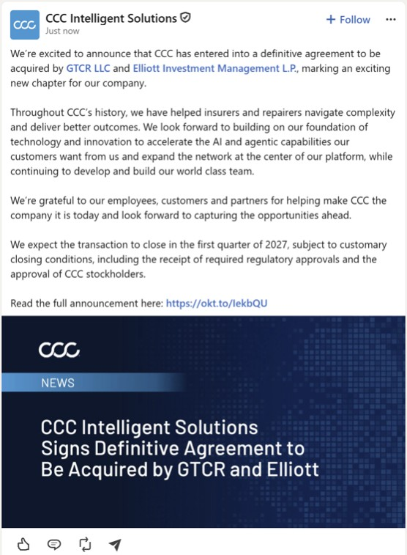

CCC Corporate Facebook Post

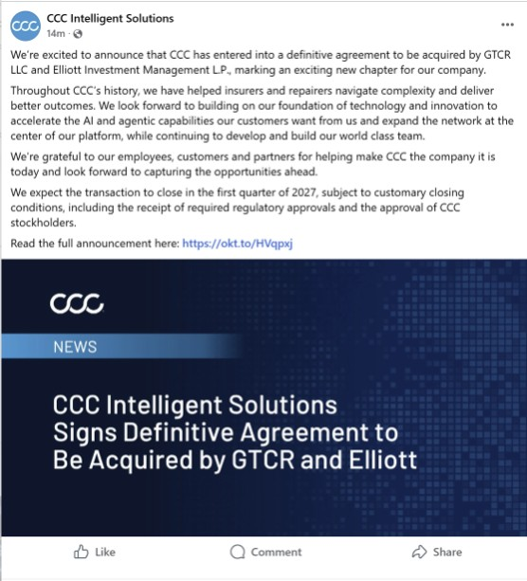

Cautionary Statement Regarding Forward-Looking Statements
This communication contains forward-looking statements within the meaning of Section 27A of the Securities Act of 1933, as amended (the “Securities Act”), and Section 21E of the Securities Exchange Act of 1934, as amended (the “Exchange Act”). In some cases, you can identify forward-looking statements by the following words: “may,” “will,” “could,” “would,” “should,” “expect,” “intend,” “plan,” “anticipate,” “believe,” “estimate,” “predict,” “project,” “potential,” “continue,” “ongoing” or the negative of these terms or other comparable terminology, although not all forward-looking statements contain these words. These statements involve risks, uncertainties and other factors that may cause actual results, levels of activity, performance or achievements to be materially different from the information expressed or implied by these forward-looking statements. Forward-looking statements in this communication include, but are not limited to, statements regarding the proposed transaction, the expected timing of completion of the transaction, the ability of the parties to consummate the transaction and the satisfaction of the conditions precedent to the consummation of the transaction, including the receipt of stockholder approval, expiration or termination of applicable waiting periods under the Hart-Scott-Rodino Antitrust Improvements Act of 1976, and the expected benefits of the transaction.
These forward-looking statements are subject to a number of risks, uncertainties and assumptions, including, among others: the occurrence of any event, change or other circumstances that could give rise to the termination of the definitive transaction documents, including circumstances requiring payment of a termination fee pursuant to the definitive transaction documents; the failure to obtain stockholder approval of the transaction or the failure to satisfy other conditions to completion of the transaction; the risk that regulatory approvals required for the transaction may not be obtained in a timely manner or at all, or may be obtained subject to conditions that are not anticipated or that could adversely affect GTCR, Elliott or the Company or the expected benefits of the transaction; the failure to satisfy the other conditions to the consummation of the transaction on a timely basis or at all; risks related to the disruption of management’s attention from the Company’s ongoing business operations due to the transaction; the effect of the announcement or pendency of the transaction on the Company’s business relationships, operating results and business generally; the risk that the transaction may not be completed in the time frame expected by the parties or at all; the risk that any announcements relating to the transaction could have adverse effects on the market price of the Company’s common stock; the risk of any unexpected costs, expenses, liabilities or delays resulting from the transaction; the risk of any litigation related to the transaction; the possibility that competing offers will be made; the risk that certain restrictions during the pendency of the proposed transaction may impact the Company’s ability to pursue certain business opportunities or strategic transactions and various other risks that could cause future results to differ from those expressed by the forward-looking statements included in this communication that are described in the Company’s reports filed with the Securities and Exchange Commission (the “SEC”), including the Company’s Annual Report on Form 10-K for the fiscal year ended December 31, 2025 and subsequently filed Quarterly Reports on Form 10-Q. You are cautioned not to place undue reliance on these forward-looking statements, which speak only as of the date of this communication. Except as required by applicable law, the Company does not undertake any obligation to publicly update or revise any forward-looking statements because of new information, future events or otherwise.

Additional Information and Where to Find It
This communication is being made in respect of the proposed acquisition of the Company by affiliates of GTCR or Elliott and related transactions (collectively, the “proposed transaction”). In accordance with the definitive transaction documents, a meeting of the stockholders of the Company will be announced as promptly as practicable to seek the Company’s stockholder approval in connection with the proposed transaction. The Company intends to file relevant materials with the SEC, including preliminary and definitive proxy statements relating to the proposed transaction. The definitive proxy statement (the “Proxy Statement”) will be mailed to the Company’s stockholders. This communication is not a substitute for the Proxy Statement or any other document that may be filed by the Company with the SEC or sent to its stockholders in connection with the proposed transaction. BEFORE MAKING ANY DECISION, THE COMPANY’S STOCKHOLDERS AND INVESTORS ARE URGED TO CAREFULLY READ THE PROXY STATEMENT (INCLUDING ANY AMENDMENTS OR SUPPLEMENTS THERETO) AND ANY OTHER RELEVANT DOCUMENTS FILED OR TO BE FILED WITH THE SEC IN CONNECTION WITH THE PROPOSED TRANSACTION OR INCORPORATED BY REFERENCE INTO THE PROXY STATEMENT AS, IF AND WHEN THEY BECOME AVAILABLE BECAUSE THEY WILL CONTAIN IMPORTANT INFORMATION ABOUT THE COMPANY, GTCR or Elliott AND THE PROPOSED TRANSACTION. Investors and security holders will be able to obtain a free copy of the Proxy Statement (when available) as well as other documents filed by the Company with the SEC through the website maintained by the SEC at www.sec.gov. Copies of the documents filed with the SEC by the Company will be available free of charge on the Company’s website at https://ir.cccis.com or by contacting the Company’s investor relations department at IR@cccis.com.
Participants in the Solicitation
The Company and its directors and executive officers may be considered participants in the solicitation of proxies from the Company’s stockholders in connection with the proposed transaction. Information about the directors and executive officers of the Company, including a description of their beneficial ownership of the Company’s securities, is set forth in the Company’s proxy statement for its 2026 annual meeting of stockholders, which was filed with the SEC on April 7, 2026 (the “Annual Meeting Proxy Statement”). To the extent the holdings of the Company’s securities by its directors or executive officers have changed since the amounts set forth in the Annual Meeting Proxy Statement, such changes have been or will be reflected on Forms 3, 4 and 5 filed with the SEC. Other information regarding the participants in the proxy solicitation and a description of their direct and indirect interests, by security holdings or otherwise, in the proposed transaction will be contained in the Proxy Statement and in other relevant materials to be filed with the SEC regarding the proposed transaction when they become available. You may obtain these documents (when they become available) as described above.

Business Update Town Hall Transcript
Good morning, everyone, and thank you for joining us.
I wanted to bring this group together to discuss the exciting news we announced this morning.
Let me start by walking you through some prepared remarks, and then we’ll open it up for questions.
Before I get into the details, I want to say thank you.
We would not be here without literally the tremendous amount of work all of you have done in terms of the company. And if you think about it, for more than 40 years, CCC has advanced the insurance economy, helping our customers move with speed through deliberate investments in technology and AI and the connected network. So today, as a scale provider of AI-based solutions, and that success has been due to both the work of this team and the trust our customers have. We see that in the conversations we have with our customers every day.
And as I mentioned in my e-mail to all of you this morning, the strong foundation we built together, paired with the opportunities we see ahead, is what brought us to this announcement. Now let me take a few minutes and walk you through what we have announced and what it means for the company.
So first, what did we announce? We have entered into a definitive agreement to be acquired by a consortium led by GTCR, including Elliott, for approximately $6.1 billion. Upon closing of the transaction, CCC will become a privately held company. Our board and management team believe this is the best path forward for our company. We considered the evolving industry landscape, and the board evaluated a number of options to determine how we can position CCC to thrive over the next 40 years and it became clear this transaction maximizes value for our shareholders and provides compelling opportunities for our company. And GTCR and Elliott are a big reason why.
And by way of background, GTCR and Elliott are leading investment firms with extensive experience supporting and growing businesses in the technology sector. GTCR has a long history of partnering with technology-enabled companies to help accelerate growth, strengthen capabilities, and support innovation. They were previously investors in CCC when the company was founded. Elliott brings broad experience in working with businesses that leverage data, software, and analytics to deliver value to their customers and drive long-term success. Together, they bring valuable perspective, resources, and experience. They’ll help support our continued growth, and they approach their partnerships with a focus on collaboration band an emphasis on building even stronger companies.
We will accelerate AI and agentic capabilities our customers want from us, expand the network at the center of our platform, and continue to develop and build our work-class team. Together, we will be well positioned to continue building on our momentum, creating intelligent solutions that keep people’s lives moving forward when it matters most. Most important for you, GDCR and Elliott recognize that our people are central to our success.
Well, this transaction will change ownership structure. It does not change who we are, what we do, or the customers we serve. Our shared values will remain core to the work we do every day. Until the transaction closes, CCC remains A publicly traded company, and we will continue to operate as an independent company. This means that roles, reporting relationships, and responsibilities will continue as usual. Our focus remains the same, delivering the technology, service and innovation our customers rely on while advancing our vision and growth strategy.

And, as you can tell...We are excited about the next chapter of CCC. But it’s important to keep in mind that this is just the beginning of a process that’ll take time to complete, and nothing is changing today.
We expect the transaction to close in the first quarter of 2027, subject to customary closing conditions, including the receipt of required regulatory approvals and the approval of CCC stockholders. Between now and closing, the most important thing each of us can do is to stay focused on your work, and continue bringing the commitment to excellence that has made CCC successful.
In closing, as we move through this process, we’ll continue sharing updates and communicating openly as important milestones are reached. Once again, thank you for your support, focus, and commitment to CCC. Our track record, combined with the talent and dedication of this team, gives me tremendous confidence in what CCC can accomplish in the years ahead.
Cautionary Statement Regarding Forward-Looking Statements
This communication contains forward-looking statements within the meaning of Section 27A of the Securities Act of 1933, as amended (the “Securities Act”), and Section 21E of the Securities Exchange Act of 1934, as amended (the “Exchange Act”). In some cases, you can identify forward-looking statements by the following words: “may,” “will,” “could,” “would,” “should,” “expect,” “intend,” “plan,” “anticipate,” “believe,” “estimate,” “predict,” “project,” “potential,” “continue,” “ongoing” or the negative of these terms or other comparable terminology, although not all forward-looking statements contain these words. These statements involve risks, uncertainties and other factors that may cause actual results, levels of activity, performance or achievements to be materially different from the information expressed or implied by these forward-looking statements. Forward-looking statements in this communication include, but are not limited to, statements regarding the proposed transaction, the expected timing of completion of the transaction, the ability of the parties to consummate the transaction and the satisfaction of the conditions precedent to the consummation of the transaction, including the receipt of stockholder approval, expiration or termination of applicable waiting periods under the Hart-Scott-Rodino Antitrust Improvements Act of 1976, and the expected benefits of the transaction.
These forward-looking statements are subject to a number of risks, uncertainties and assumptions, including, among others: the occurrence of any event, change or other circumstances that could give rise to the termination of the definitive transaction documents, including circumstances requiring payment of a termination fee pursuant to the definitive transaction documents; the failure to obtain stockholder approval of the transaction or the failure to satisfy other conditions to completion of the transaction; the risk that regulatory approvals required for the transaction may not be obtained in a timely manner or at all, or may be obtained subject to conditions that are not anticipated or that could adversely affect GTCR, Elliott or the Company or the expected benefits of the transaction; the failure to satisfy the other conditions to the consummation of the transaction on a timely basis or at all; risks related to the disruption of management’s attention from the Company’s ongoing business operations due to the transaction; the effect of the announcement or pendency of the transaction on the Company’s business relationships, operating results and business generally; the risk that the transaction may not be completed in the time frame expected by the parties or at all; the risk that any announcements relating to the transaction could have adverse effects on the market price of the Company’s common stock; the risk of any unexpected costs, expenses, liabilities or delays resulting from the transaction; the risk of any litigation related to the transaction; the possibility that competing offers will be made; the risk that certain restrictions during the pendency of the proposed transaction may impact the Company’s ability to pursue certain business opportunities or strategic transactions and various other risks that could cause future results to differ from those expressed by the forward-looking statements included in this communication that are described in the Company’s reports filed with the Securities and Exchange Commission (the “SEC”), including the Company’s Annual Report on Form 10-K for the fiscal year ended December 31, 2025 and subsequently filed Quarterly Reports on Form 10-Q. You are cautioned not to place undue reliance on these forward-looking statements, which speak only as of the date of this communication. Except as required by applicable law, the Company does not undertake any obligation to publicly update or revise any forward-looking statements because of new information, future events or otherwise.

Additional Information and Where to Find It
This communication is being made in respect of the proposed acquisition of the Company by affiliates of GTCR or Elliott and related transactions (collectively, the “proposed transaction”). In accordance with the definitive transaction documents, a meeting of the stockholders of the Company will be announced as promptly as practicable to seek the Company’s stockholder approval in connection with the proposed transaction. The Company intends to file relevant materials with the SEC, including preliminary and definitive proxy statements relating to the proposed transaction. The definitive proxy statement (the “Proxy Statement”) will be mailed to the Company’s stockholders. This communication is not a substitute for the Proxy Statement or any other document that may be filed by the Company with the SEC or sent to its stockholders in connection with the proposed transaction. BEFORE MAKING ANY DECISION, THE COMPANY’S STOCKHOLDERS AND INVESTORS ARE URGED TO CAREFULLY READ THE PROXY STATEMENT (INCLUDING ANY AMENDMENTS OR SUPPLEMENTS THERETO) AND ANY OTHER RELEVANT DOCUMENTS FILED OR TO BE FILED WITH THE SEC IN CONNECTION WITH THE PROPOSED TRANSACTION OR INCORPORATED BY REFERENCE INTO THE PROXY STATEMENT AS, IF AND WHEN THEY BECOME AVAILABLE BECAUSE THEY WILL CONTAIN IMPORTANT INFORMATION ABOUT THE COMPANY, GTCR or Elliott AND THE PROPOSED TRANSACTION. Investors and security holders will be able to obtain a free copy of the Proxy Statement (when available) as well as other documents filed by the Company with the SEC through the website maintained by the SEC at www.sec.gov. Copies of the documents filed with the SEC by the Company will be available free of charge on the Company’s website at https://ir.cccis.com or by contacting the Company’s investor relations department at IR@cccis.com.
Participants in the Solicitation
The Company and its directors and executive officers may be considered participants in the solicitation of proxies from the Company’s stockholders in connection with the proposed transaction. Information about the directors and executive officers of the Company, including a description of their beneficial ownership of the Company’s securities, is set forth in the Company’s proxy statement for its 2026 annual meeting of stockholders, which was filed with the SEC on April 7, 2026 (the “Annual Meeting Proxy Statement”). To the extent the holdings of the Company’s securities by its directors or executive officers have changed since the amounts set forth in the Annual Meeting Proxy Statement, such changes have been or will be reflected on Forms 3, 4 and 5 filed with the SEC. Other information regarding the participants in the proxy solicitation and a description of their direct and indirect interests, by security holdings or otherwise, in the proposed transaction will be contained in the Proxy Statement and in other relevant materials to be filed with the SEC regarding the proposed transaction when they become available. You may obtain these documents (when they become available) as described above.

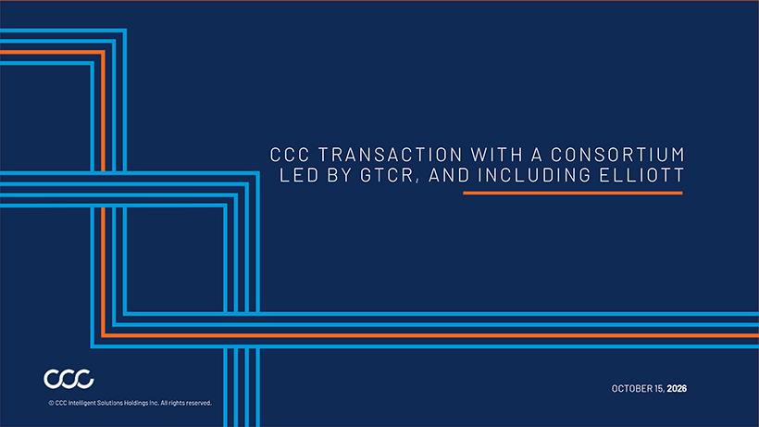
CCC TRANSACTION WITH A CONSORTIUM LED BY GTCR , AND INCLUDING ELLIOTT

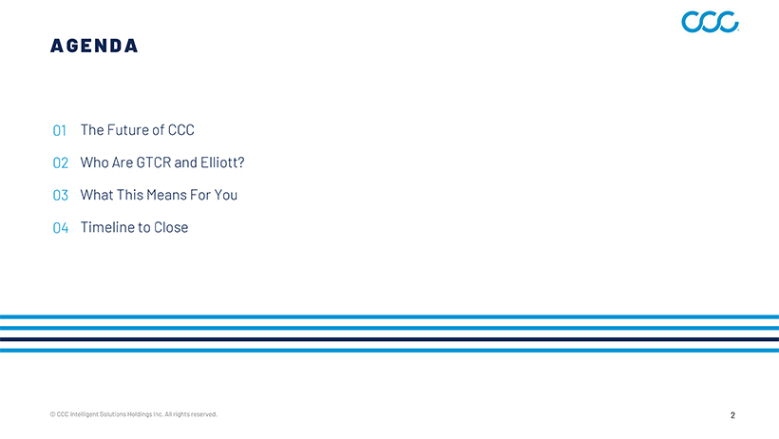
A G E N D A © CCC Intelligent Solutions Holdings Inc. All rights reserved. 2 The Future of CCC Who Are GTCR and Elliott? What This Means For You Timeline to Close

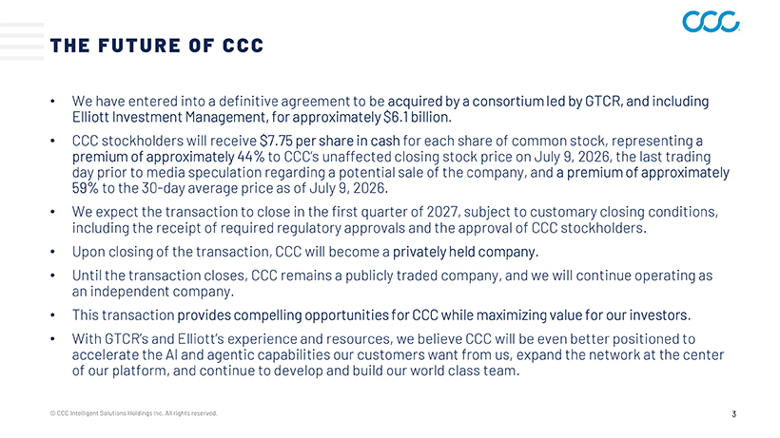
THE FUTURE OF CCC  We have entered into a definitive agreement to be acquired by a consortium led by GTCR, and including Elliott Investment Management, for approximately $6.1 billion.  CCC stockholders will receive $7.75 per share in cash for each share of common stock, representing a premium of approximately 44% to CCC’s unaffected closing stock price on July 9, 2026, the last trading day prior to media speculation regarding a potential sale of the company, and a premium of approximately 59% to the 30-day average price as of July 9, 2026.  We expect the transaction to close in the first quarter of 2027, subject to customary closing conditions, including the receipt of required regulatory approvals and the approval of CCC stockholders.  Upon closing of the transaction, CCC will become a privately held company.  Until the transaction closes, CCC remains a publicly traded company, and we will continue operating as an independent company.  This transaction provides compelling opportunities for CCC while maximizing value for our investors.  With GTCR’s and Elliott’s experience and resources, we believe CCC will be even better positioned to accelerate the AI and agentic capabilities our customers want from us, expand the network at the center of our platform, and continue to develop and build our world class team.

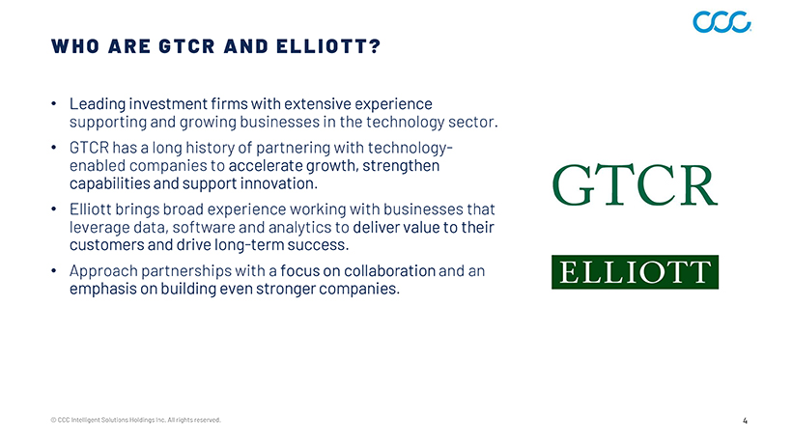
WHO ARE GTCR AND ELLIOTT ?  Leading investment firms with extensive experience supporting and growing businesses in the technology sector.  GTCR has a long history of partnering with technologyenabled companies to accelerate growth, strengthen capabilities and support innovation.  Elliott brings broad experience working with businesses that leverage data, software and analytics to deliver value to their customers and drive long-term success.  Approach partnerships with a focus on collaboration and an emphasis on building even stronger companies.

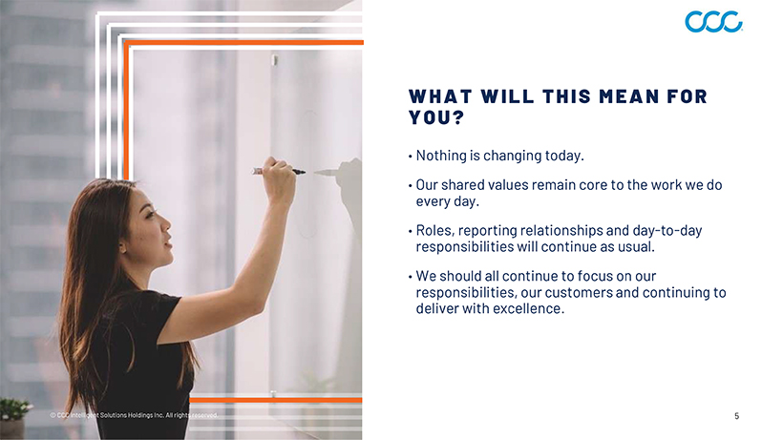
WHAT WILL THIS MEAN FOR YOU ?  Nothing is changing today.  Our shared values remain core to the work we do every day.  Roles, reporting relationships and day-to-day responsibilities will continue as usual.  We should all continue to focus on our responsibilities, our customers and continuing to deliver with excellence.

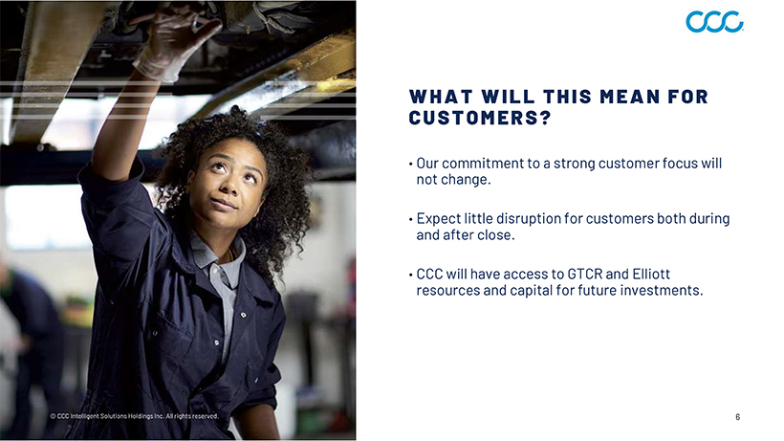
WHAT WILL THIS MEAN FOR CUSTOMERS ?  Our commitment to a strong customer focus will not change.  Expect little disruption for customers both during and after close.  CCC will have access to GTCR and Elliott resources and capital for future investments.

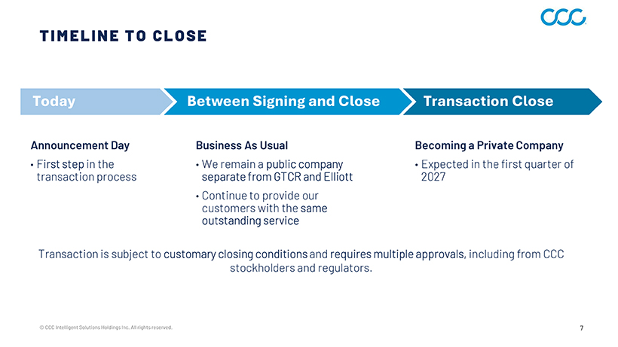
TIMELINE TO CLOSE Today Between Signing and Close Transaction Close Announcement Day  First step in the transaction process © CCC Intelligent Solutions Holdings Inc. All rights reserved. 7 Business As Usual  We remain a public company separate from GTCR and Elliott  Continue to provide our customers with the same outstanding service Becoming a Private Company  Expected in the first quarter of 2027 Transaction is subject to customary closing conditions and requires multiple approvals, including from CCC stockholders and regulators.

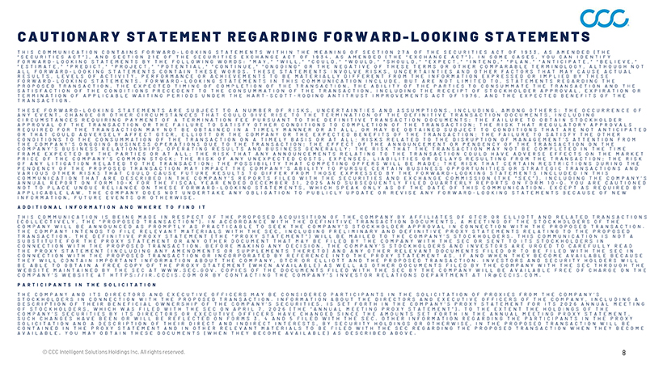
C A U T I O N A R Y S T A T E M E N T R E G A R D I N G F O R W A R D—L O O K I N G S T A T E M E N T S T H I S C O M M U N I C A T I O N C O N T A I N S F O R W A R D—L O O K I N G S T A T E M E N T S W I T H I N T H E M E A N I N G O F S E C T I O N 2 7 A O F T H E S E C U R I T I E S A C T O F 1 9 3 3 , A S A M E N D E D ( T H E “ S E C U R I T I E S A C T ” ) , A N D S E C T I O N 2 1 E O F T H E S E C U R I T I E S E X C H A N G E A C T O F 1 9 3 4 , A S A M E N D E D ( T H E “ E X C H A N G E A C T ” ) . I N S O M E C A S E S , Y O U C A N I D E N T I F Y F O R W A R D—L O O K I N G S T A T E M E N T S B Y T H E F O L L O W I N G W O R D S : “ M A Y , ” “ W I L L , ” “ C O U L D , ” “ W O U L D , ” “ S H O U L D , ” “ E X P E C T , ” “ I N T E N D , ” “ P L A N , ” “ A N T I C I P A T E , ” “ B E L I E V E , ” “ E S T I M A T E , ” “ P R E D I C T , ” “ P R O J E C T , ” “ P O T E N T I A L , ” “ C O N T I N U E , ” “ O N G O I N G ” O R T H E N E G A T I V E O F T H E S E T E R M S O R O T H E R C O M P A R A B L E T E R M I N O L O G Y , A L T H O U G H N O T A L L F O R W A R D—L O O K I N G S T A T E M E N T S C O N T A I N T H E S E W O R D S . T H E S E S T A T E M E N T S I N V O L V E R I S K S , U N C E R T A I N T I E S A N D O T H E R F A C T O R S T H A T M A Y C A U S E A C T U A L R E S U L T S , L E V E L S O F A C T I V I T Y , P E R F O R M A N C E O R A C H I E V E M E N T S T O B E M A T E R I A L L Y D I F F E R E N T F R O M T H E I N F O R M A T I O N E X P R E S S E D O R I M P L I E D B Y T H E S E F O R W A R D—L O O K I N G S T A T E M E N T S . F O R W A R D—L O O K I N G S T A T E M E N T S I N T H I S C O M M U N I C A T I O N I N C L U D E , B U T A R E N O T L I M I T E D T O , S T A T E M E N T S R E G A R D I N G T H E P R O P O S E D T R A N S A C T I O N , T H E E X P E C T E D T I M I N G O F C O M P L E T I O N O F T H E T R A N S A C T I O N , T H E A B I L I T Y O F T H E P A R T I E S T O C O N S U M M A T E T H E T R A N S A C T I O N A N D T H E S A T I S F A C T I O N O F T H E C O N D I T I O N S P R E C E D E N T T O T H E C O N S U M M A T I O N O F T H E T R A N S A C T I O N , I N C L U D I N G T H E R E C E I P T O F S T O C K H O L D E R A P P R O V A L , E X P I R A T I O N O R T E R M I N A T I O N O F A P P L I C A B L E W A I T I N G P E R I O D S U N D E R T H E H A R T—S C O T T—R O D I N O A N T I T R U S T I M P R O V E M E N T S A C T O F 1 9 7 6 , A N D T H E E X P E C T E D B E N E F I T S O F T H E T R A N S A C T I O N . T H E S E F O R W A R D—L O O K I N G S T A T E M E N T S A R E S U B J E C T T O A N U M B E R O F R I S K S , U N C E R T A I N T I E S A N D A S S U M P T I O N S , I N C L U D I N G , A M O N G O T H E R S : T H E O C C U R R E N C E O F A N Y E V E N T , C H A N G E O R O T H E R C I R C U M S T A N C E S T H A T C O U L D G I V E R I S E T O T H E T E R M I N A T I O N O F T H E D E F I N I T I V E T R A N S A C T I O N D O C U M E N T S , I N C L U D I N G C I R C U M S T A N C E S R E Q U I R I N G P A Y M E N T O F A T E R M I N A T I O N F E E P U R S U A N T T O T H E D E F I N I T I V E T R A N S A C T I O N D O C U M E N T S ; T H E F A I L U R E T O O B T A I N S T O C K H O L D E R A P P R O V A L O F T H E T R A N S A C T I O N O R T H E F A I L U R E T O S A T I S F Y O T H E R C O N D I T I O N S T O C O M P L E T I O N O F T H E T R A N S A C T I O N ; T H E R I S K T H A T R E G U L A T O R Y A P P R O V A L S R E Q U I R E D F O R T H E T R A N S A C T I O N M A Y N O T B E O B T A I N E D I N A T I M E L Y M A N N E R O R A T A L L , O R M A Y B E O B T A I N E D S U B J E C T T O C O N D I T I O N S T H A T A R E N O T A N T I C I P A T E D O R T H A T C O U L D A D V E R S E L Y A F F E C T G T C R , E L L I O T T O R T H E C O M P A N Y O R T H E E X P E C T E D B E N E F I T S O F T H E T R A N S A C T I O N ; T H E F A I L U R E T O S A T I S F Y T H E O T H E R C O N D I T I O N S T O T H E C O N S U M M A T I O N O F T H E T R A N S A C T I O N O N A T I M E L Y B A S I S O R A T A L L ; R I S K S R E L A T E D T O T H E D I S R U P T I O N O F M A N A G E M E N T ’ S A T T E N T I O N F R O M T H E C O M P A N Y ’ S O N G O I N G B U S I N E S S O P E R A T I O N S D U E T O T H E T R A N S A C T I O N ; T H E E F F E C T O F T H E A N N O U N C E M E N T O R P E N D E N C Y O F T H E T R A N S A C T I O N O N T H E C O M P A N Y ’ S B U S I N E S S R E L A T I O N S H I P S , O P E R A T I N G R E S U L T S A N D B U S I N E S S G E N E R A L L Y ; T H E R I S K T H A T T H E T R A N S A C T I O N M A Y N O T B E C O M P L E T E D I N T H E T I M E F R A M E E X P E C T E D B Y T H E P A R T I E S O R A T A L L ; T H E R I S K T H A T A N Y A N N O U N C E M E N T S R E L A T I N G T O T H E T R A N S A C T I O N C O U L D H A V E A D V E R S E E F F E C T S O N T H E M A R K E T P R I C E O F T H E C O M P A N Y ’ S C O M M O N S T O C K ; T H E R I S K O F A N Y U N E X P E C T E D C O S T S , E X P E N S E S , L I A B I L I T I E S O R D E L A Y S R E S U L T I N G F R O M T H E T R A N S A C T I O N ; T H E R I S K O F A N Y L I T I G A T I O N R E L A T E D T O T H E T R A N S A C T I O N ; T H E P O S S I B I L I T Y T H A T C O M P E T I N G O F F E R S W I L L B E M A D E ; T H E R I S K T H A T C E R T A I N R E S T R I C T I O N S D U R I N G T H E P E N D E N C Y O F T H E P R O P O S E D T R A N S A C T I O N M A Y I M P A C T T H E C O M P A N Y ’ S A B I L I T Y T O P U R S U E C E R T A I N B U S I N E S S O P P O R T U N I T I E S O R S T R A T E G I C T R A N S A C T I O N S A N D V A R I O U S O T H E R R I S K S T H A T C O U L D C A U S E F U T U R E R E S U L T S T O D I F F E R F R O M T H O S E E X P R E S S E D B Y T H E F O R W A R D—L O O K I N G S T A T E M E N T S I N C L U D E D I N T H I S C O M M U N I C A T I O N T H A T A R E D E S C R I B E D I N T H E C O M P A N Y ’ S R E P O R T S F I L E D W I T H T H E S E C U R I T I E S A N D E X C H A N G E C O M M I S S I O N ( T H E “ S E C ” ) , I N C L U D I N G T H E C O M P A N Y ’ S A N N U A L R E P O R T O N F O R M 1 0—K F O R T H E F I S C A L Y E A R E N D E D D E C E M B E R 3 1 , 2 0 2 5 A N D S U B S E Q U E N T L Y F I L E D Q U A R T E R L Y R E P O R T S O N F O R M 1 0—Q . Y O U A R E C A U T I O N E D N O T T O P L A C E U N D U E R E L I A N C E O N T H E S E F O R W A R D—L O O K I N G S T A T E M E N T S , W H I C H S P E A K O N L Y A S O F T H E D A T E O F T H I S C O M M U N I C A T I O N . E X C E P T A S R E Q U I R E D B Y A P P L I C A B L E L A W , T H E C O M P A N Y D O E S N O T U N D E R T A K E A N Y O B L I G A T I O N T O P U B L I C L Y U P D A T E O R R E V I S E A N Y F O R W A R D—L O O K I N G S T A T E M E N T S B E C A U S E O F N E W I N F O R M A T I O N , F U T U R E E V E N T S O R O T H E R W I S E . A D D I T I O N A L I N F O R M A T I O N A N D W H E R E T O F I N D I T T H I S C O M M U N I C A T I O N I S B E I N G M A D E I N R E S P E C T O F T H E P R O P O S E D A C Q U I S I T I O N O F T H E C O M P A N Y B Y A F F I L I A T E S O F G T C R O R E L L I O T T A N D R E L A T E D T R A N S A C T I O N S ( C O L L E C T I V E L Y , T H E “ P R O P O S E D T R A N S A C T I O N ” ) . I N A C C O R D A N C E W I T H T H E D E F I N I T I V E T R A N S A C T I O N D O C U M E N T S , A M E E T I N G O F T H E S T O C K H O L D E R S O F T H E C O M P A N Y W I L L B E A N N O U N C E D A S P R O M P T L Y A S P R A C T I C A B L E T O S E E K T H E C O M P A N Y ’ S S T O C K H O L D E R A P P R O V A L I N C O N N E C T I O N W I T H T H E P R O P O S E D T R A N S A C T I O N . T H E C O M P A N Y I N T E N D S T O F I L E R E L E V A N T M A T E R I A L S W I T H T H E S E C , I N C L U D I N G P R E L I M I N A R Y A N D D E F I N I T I V E P R O X Y S T A T E M E N T S R E L A T I N G T O T H E P R O P O S E D T R A N S A C T I O N . T H E D E F I N I T I V E P R O X Y S T A T E M E N T ( T H E “ P R O X Y S T A T E M E N T ” ) W I L L B E M A I L E D T O T H E C O M P A N Y ’ S S T O C K H O L D E R S . T H I S C O M M U N I C A T I O N I S N O T A S U B S T I T U T E F O R T H E P R O X Y S T A T E M E N T O R A N Y O T H E R D O C U M E N T T H A T M A Y B E F I L E D B Y T H E C O M P A N Y W I T H T H E S E C O R S E N T T O I T S S T O C K H O L D E R S I N C O N N E C T I O N W I T H T H E P R O P O S E D T R A N S A C T I O N . B E F O R E M A K I N G A N Y D E C I S I O N , T H E C O M P A N Y ’ S S T O C K H O L D E R S A N D I N V E S T O R S A R E U R G E D T O C A R E F U L L Y R E A D T H E P R O X Y S T A T E M E N T ( I N C L U D I N G A N Y A M E N D M E N T S O R S U P P L E M E N T S T H E R E T O ) A N D A N Y O T H E R R E L E V A N T D O C U M E N T S F I L E D O R T O B E F I L E D W I T H T H E S E C I N C O N N E C T I O N W I T H T H E P R O P O S E D T R A N S A C T I O N O R I N C O R P O R A T E D B Y R E F E R E N C E I N T O T H E P R O X Y S T A T E M E N T A S , I F A N D W H E N T H E Y B E C O M E A V A I L A B L E B E C A U S E T H E Y W I L L C O N T A I N I M P O R T A N T I N F O R M A T I O N A B O U T T H E C O M P A N Y , G T C R O R E L L I O T T A N D T H E P R O P O S E D T R A N S A C T I O N . I N V E S T O R S A N D S E C U R I T Y H O L D E R S W I L L B E A B L E T O O B T A I N A F R E E C O P Y O F T H E P R O X Y S T A T E M E N T ( W H E N A V A I L A B L E ) A S W E L L A S O T H E R D O C U M E N T S F I L E D B Y T H E C O M P A N Y W I T H T H E S E C T H R O U G H T H E W E B S I T E M A I N T A I N E D B Y T H E S E C A T W W W . S E C . G O V . C O P I E S O F T H E D O C U M E N T S F I L E D W I T H T H E S E C B Y T H E C O M P A N Y W I L L B E A V A I L A B L E F R E E O F C H A R G E O N T H E C O M P A N Y ’ S W E B S I T E A T H T T P S : / / I R . C C C I S . C O M O R B Y C O N T A C T I N G T H E C O M P A N Y ’ S I N V E S T O R R E L A T I O N S D E P A R T M E N T A T I R @ C C C I S . C O M . P A R T I C I P A N T S I N T H E S O L I C I T A T I O N T H E C O M P A N Y A N D I T S D I R E C T O R S A N D E X E C U T I V E O F F I C E R S M A Y B E C O N S I D E R E D P A R T I C I P A N T S I N T H E S O L I C I T A T I O N O F P R O X I E S F R O M T H E C O M P A N Y ’ S S T O C K H O L D E R S I N C O N N E C T I O N W I T H T H E P R O P O S E D T R A N S A C T I O N . I N F O R M A T I O N A B O U T T H E D I R E C T O R S A N D E X E C U T I V E O F F I C E R S O F T H E C O M P A N Y , I N C L U D I N G A D E S C R I P T I O N O F T H E I R B E N E F I C I A L O W N E R S H I P O F T H E C O M P A N Y ’ S S E C U R I T I E S , I S S E T F O R T H I N T H E C O M P A N Y ’ S P R O X Y S T A T E M E N T F O R I T S 2 0 2 6 A N N U A L M E E T I N G O F S T O C K H O L D E R S , W H I C H W A S F I L E D W I T H T H E S E C O N A P R I L 7 , 2 0 2 6 ( T H E “ A N N U A L M E E T I N G P R O X Y S T A T E M E N T ” ) . T O T H E E X T E N T T H E H O L D I N G S O F T H E C O M P A N Y ’ S S E C U R I T I E S B Y I T S D I R E C T O R S O R E X E C U T I V E O F F I C E R S H A V E C H A N G E D S I N C E T H E A M O U N T S S E T F O R T H I N T H E A N N U A L M E E T I N G P R O X Y S T A T E M E N T , S U C H C H A N G E S H A V E B E E N O R W I L L B E R E F L E C T E D O N F O R M S 3 , 4 A N D 5 F I L E D W I T H T H E S E C . O T H E R I N F O R M A T I O N R E G A R D I N G T H E P A R T I C I P A N T S I N T H E P R O X Y S O L I C I T A T I O N A N D A D E S C R I P T I O N O F T H E I R D I R E C T A N D I N D I R E C T I N T E R E S T S , B Y S E C U R I T Y H O L D I N G S O R O T H E R W I S E , I N T H E P R O P O S E D T R A N S A C T I O N W I L L B E C O N T A I N E D I N T H E P R O X Y S T A T E M E N T A N D I N O T H E R R E L E V A N T M A T E R I A L S T O B E F I L E D W I T H T H E S E C R E G A R D I N G T H E P R O P O S E D T R A N S A C T I O N W H E N T H E Y B E C O M E A V A I L A B L E . Y O U M A Y O B T A I N T H E S E D O C U M E N T S ( W H E N T H E Y B E C O M E A V A I L A B L E ) A S D E S C R I B E D A B O V E .


© CCC Intelligent Solutions Holdings Inc. All rights reserved.

